**RDBMS LAB-6**

***Run at least two examples for each of the queries (Online: https://sqliteonline.com/)***

**1. List all distinct values for a column.**

SQL> select distinct(job) from emp;

SQL> select distint(job) from emp where deptno=20; (where clause is optional)

**EXAMPLE 1:**

**CODE:**

CREATE TABLE emp(

name varchar(255),

job varchar(255),

salary int);

INSERT into emp values ("nikhil","engineer",25000),("ankita","doctor",500000),("vikrant","driver",300);

SELECT DISTINCT(job) from emp;

**OUTPUT:**

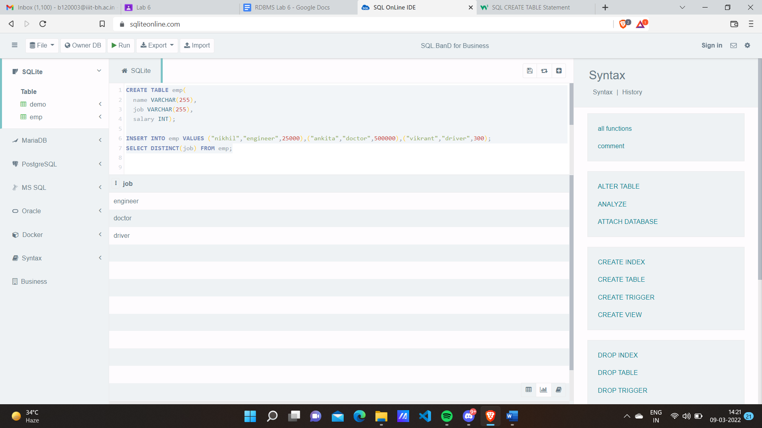

**EXAMPLE 2:**

**CODE:**

CREATE TABLE emp(

name varchar(255),

job varchar(255),

salary int);

INSERT into emp values ("nikhil","engineer",25000),("ankita","doctor",500000),("vikrant","driver",300);

SELECT DISTINCT(name) from emp WHERE job="engineer";

**OUTPUT:**

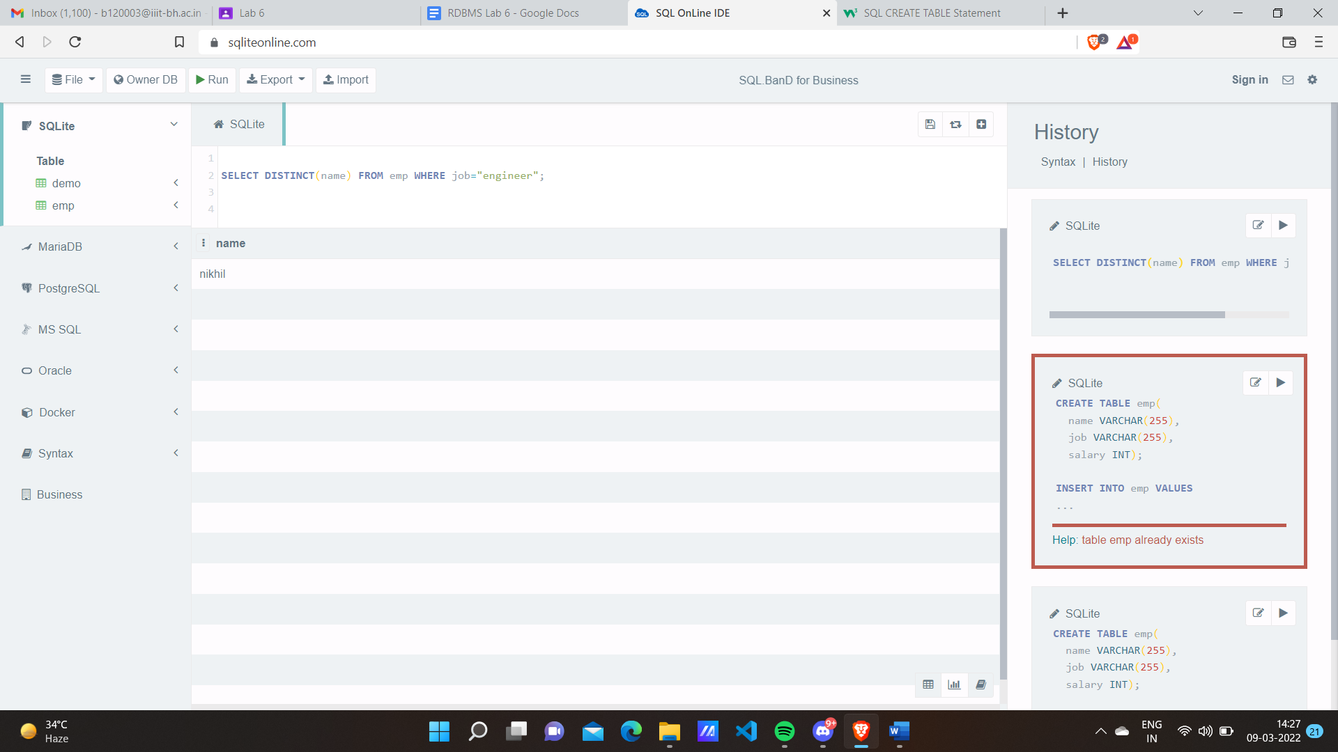

**2. List employee names whose salary is between 2000 and 3000.**

SQL>Select ename,sal from emp where sal between 2000 and 3000;

**EXAMPLE 1:**

**CODE:**

CREATE TABLE emp(

name varchar(255),

job varchar(255),

salary int);

INSERT into emp values ("nikhil","engineer",25000),("ankita","doctor",500000),("vikrant","driver",300), ("aditya","barber",2500),("priyanka","doctor",2800);

Select name,salary from emp where salary between 2000 and 3000;

**OUTPUT:**

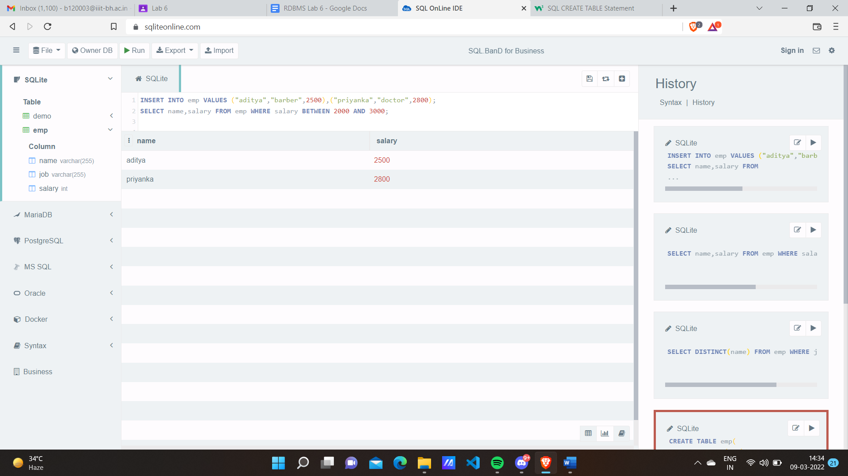

**EXAMPLE 2:**

**CODE:**

CREATE table flowers(

name varchar(255),

price varchar(255));

insert into flowers VALUES("rose",80),("sunflower",180),("lily",200),("marigold",50),("jasmine",150);

SELECT name from flowers WHERE price between 100 and 200;

**OUTPUT:**

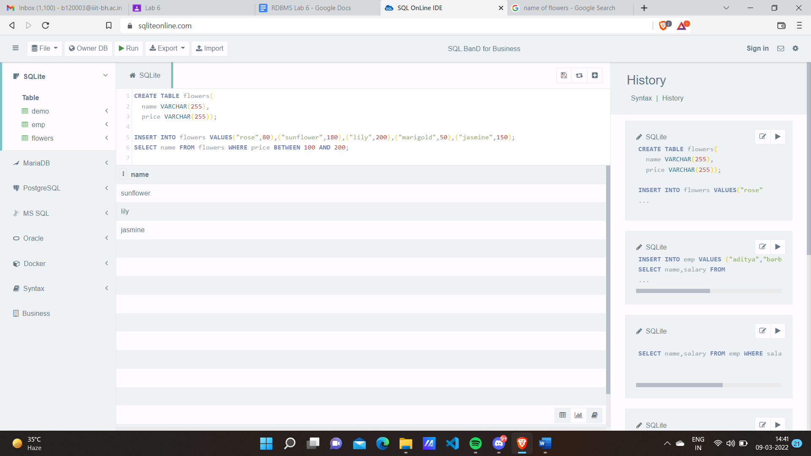

**3. List employee in the dependent 10,20. (specifically selects from the given list, list can be more)** SQL>select * from emp where deptno in(10,20);

**EXAMPLE 1:**

**CODE:**

SELECT*from flowers where price in(80,200);

**OUTPUT:**

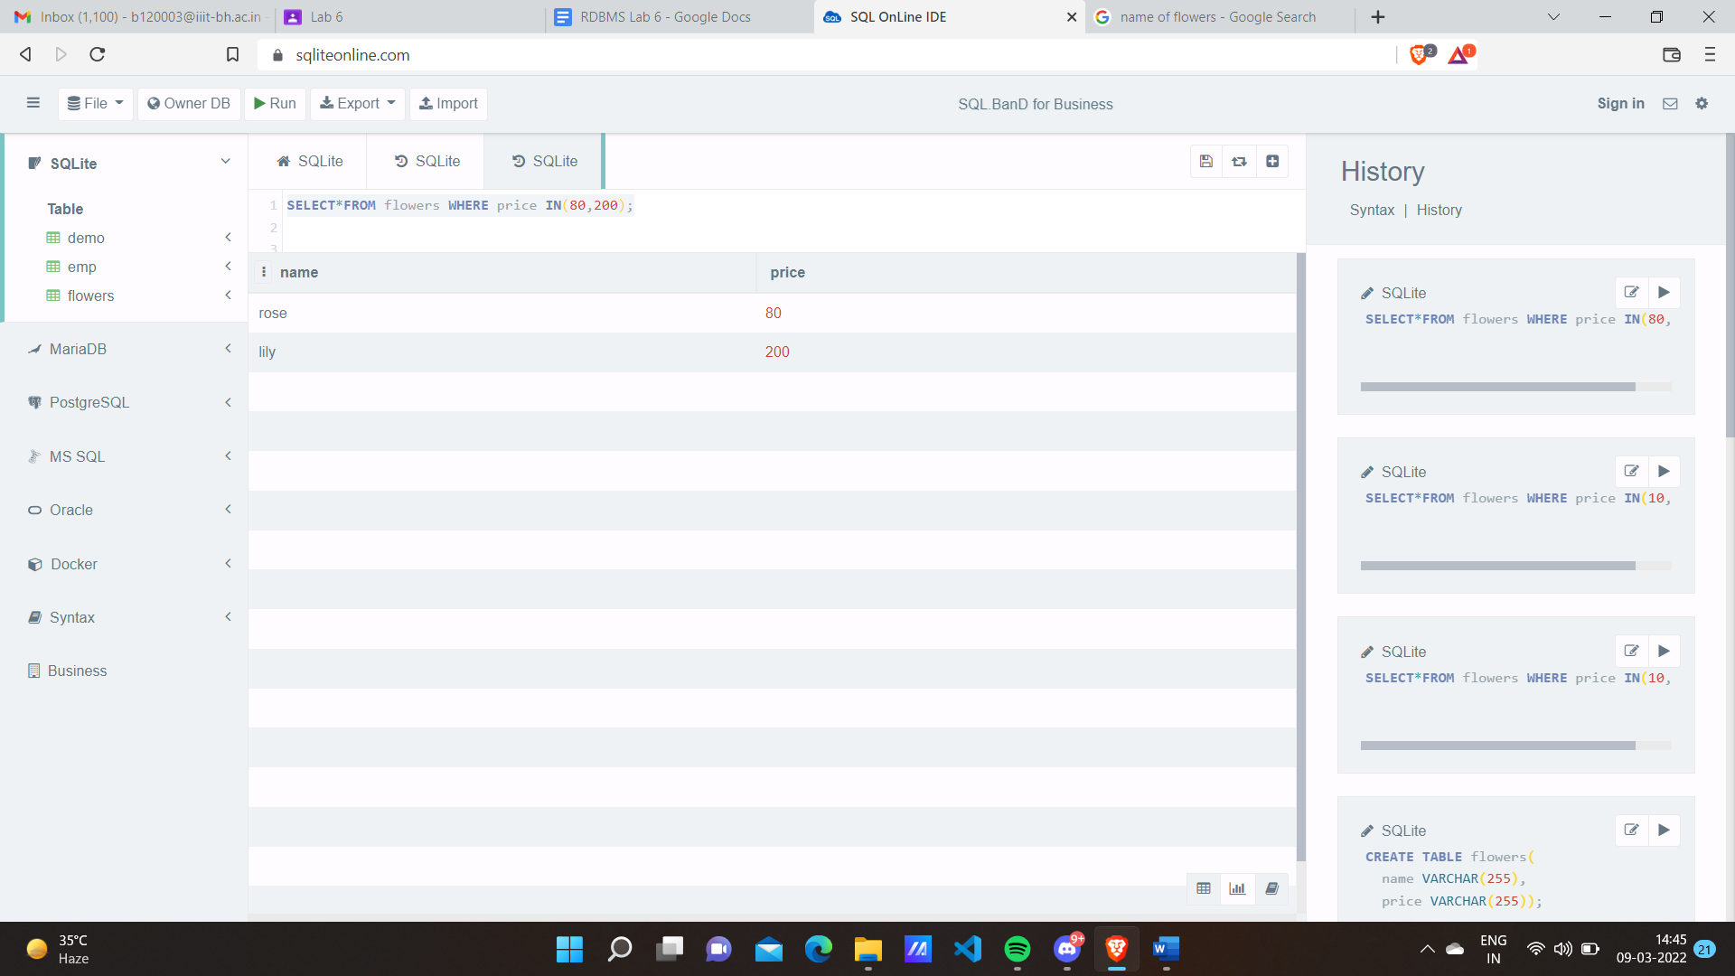

**EXAMPLE 2:**

**CODE:**

SELECT*from emp where salary in(25000,300);

**OUTPUT:**

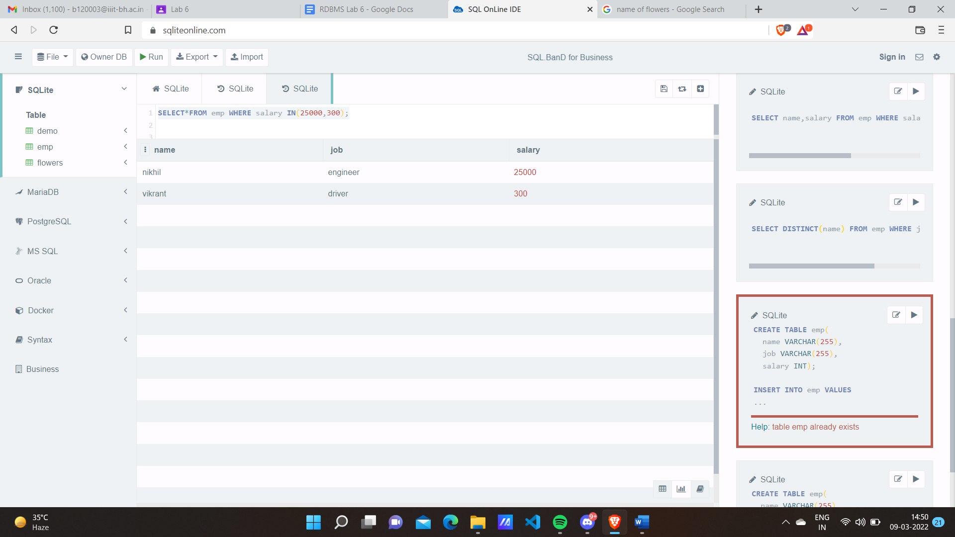

***4.* List employee names which begin with S.**

SQL>select ename from emp where ename like ‘S%’;

**EXAMPLE 1:**

**CODE:**

CREATE TABLE emp(

name varchar(255),

job varchar(255),

salary int);

INSERT into emp values ("sanket","engineer",25000),("swoyam","doctor",500000),("vikrant","driver",300), ("aditya","barber",2500),("priyanka","doctor",2800);

select name from emp where name like "s%";

**OUTPUT:**

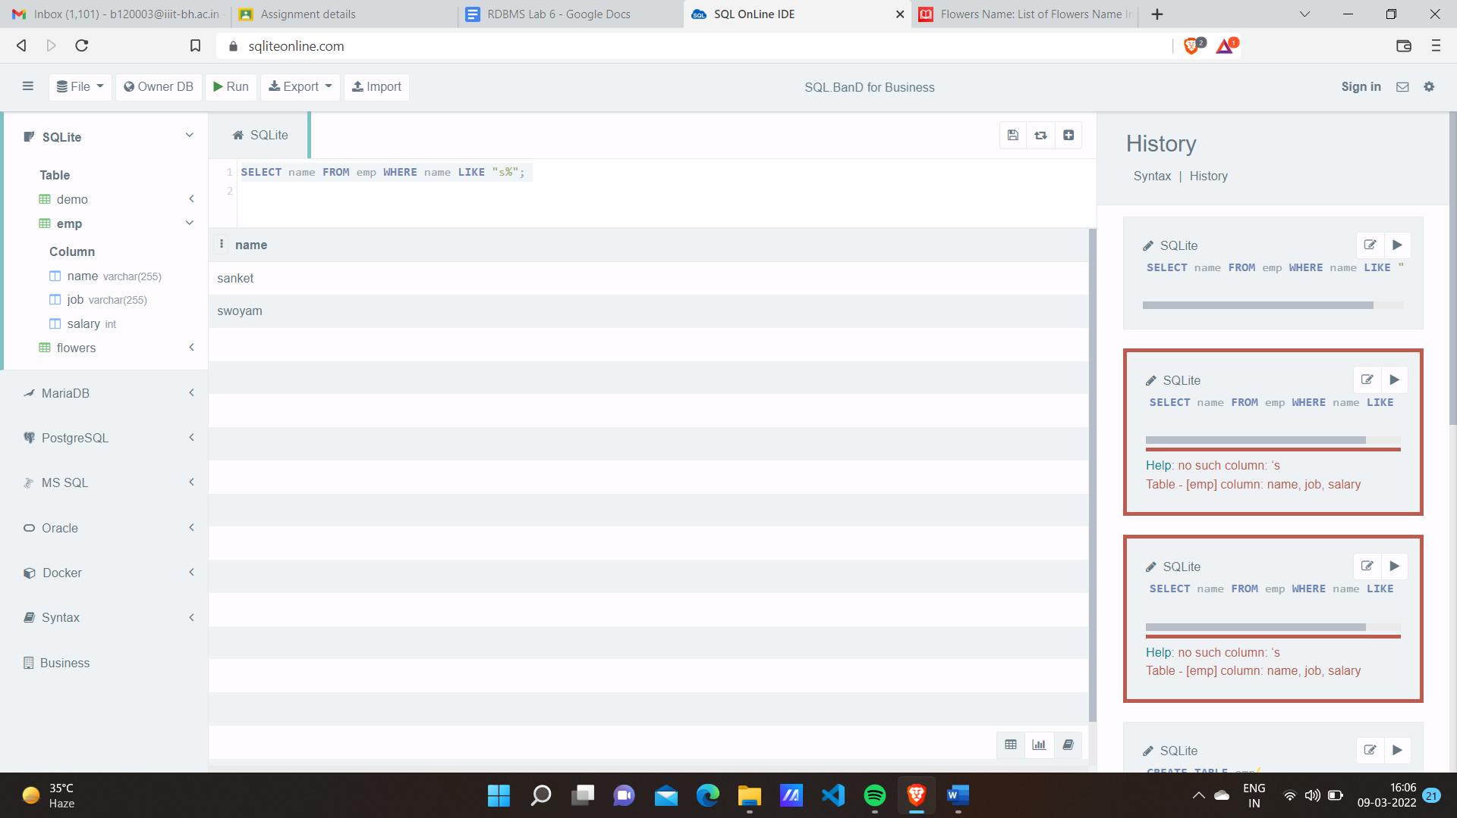

**EXAMPLE 2:**

**CODE:**

CREATE table flowers(

name varchar(255),

price varchar(255));

insert into flowers VALUES("rose",80),("sunflower",180),("lily",200),("marigold",50),("jasmine",150),("calendula",70),("iris",60);

SELECT name from flowers WHERE name like "s%";

**OUTPUT:**

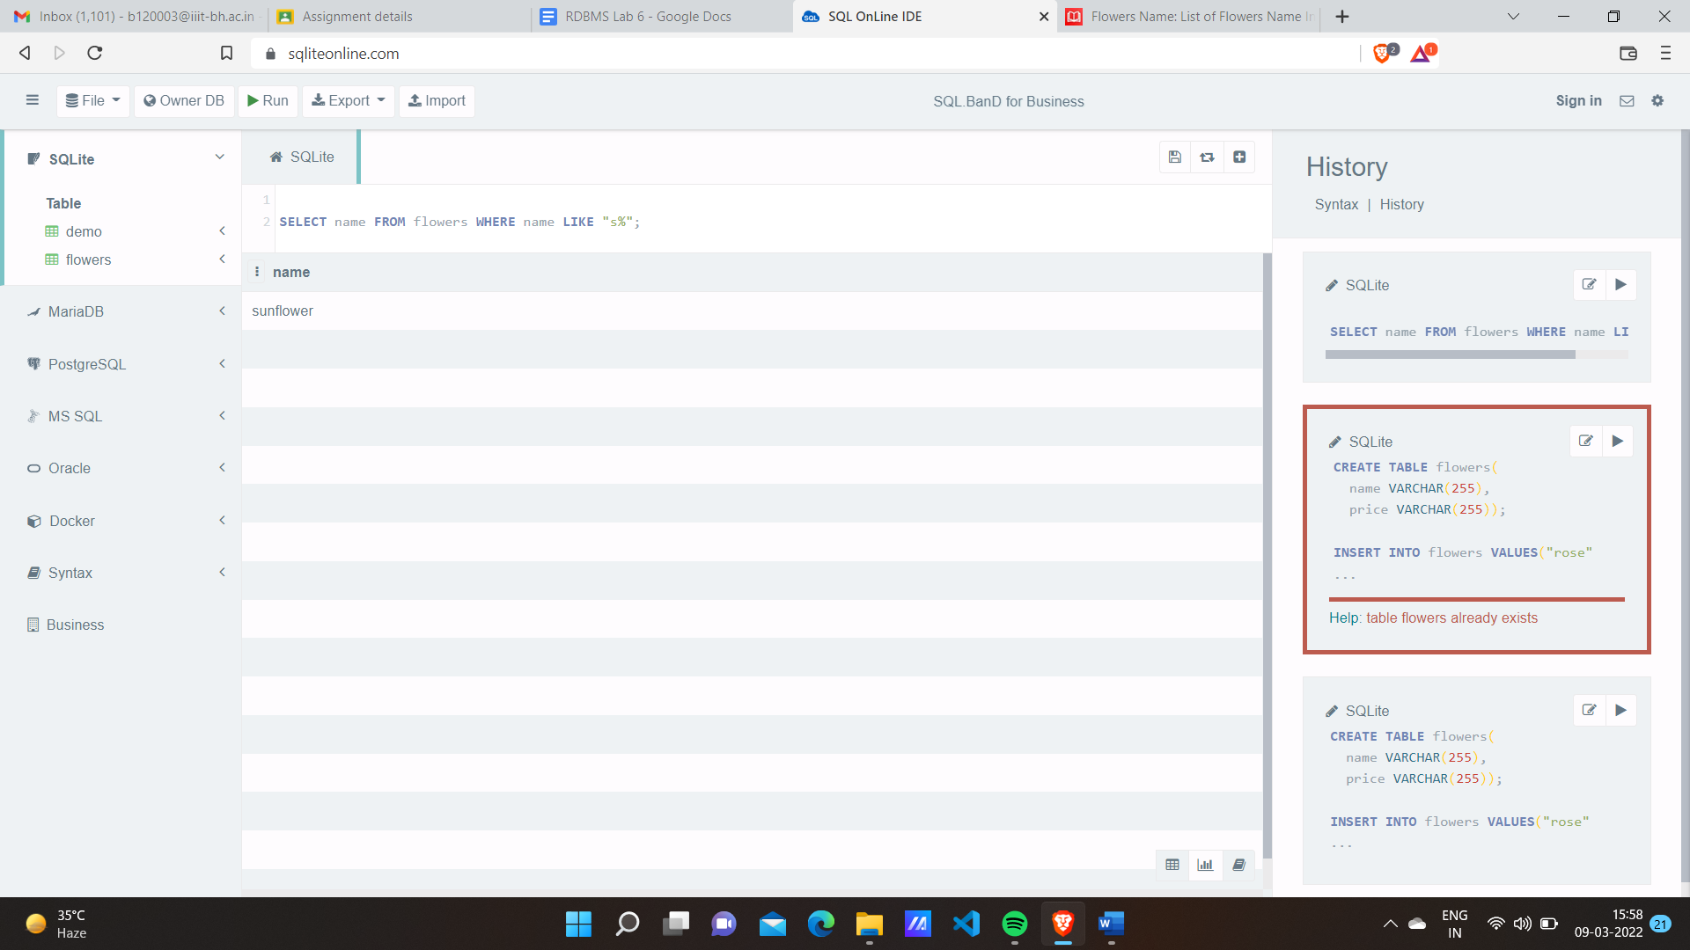

**5. List employee names having ‘A’ in their names.**

SQL>select ename from emp where ename like ‘%A%’;

**EXAMPLE 1:**

**CODE:**

select name from emp where name like "a%";

**OUTPUT:**

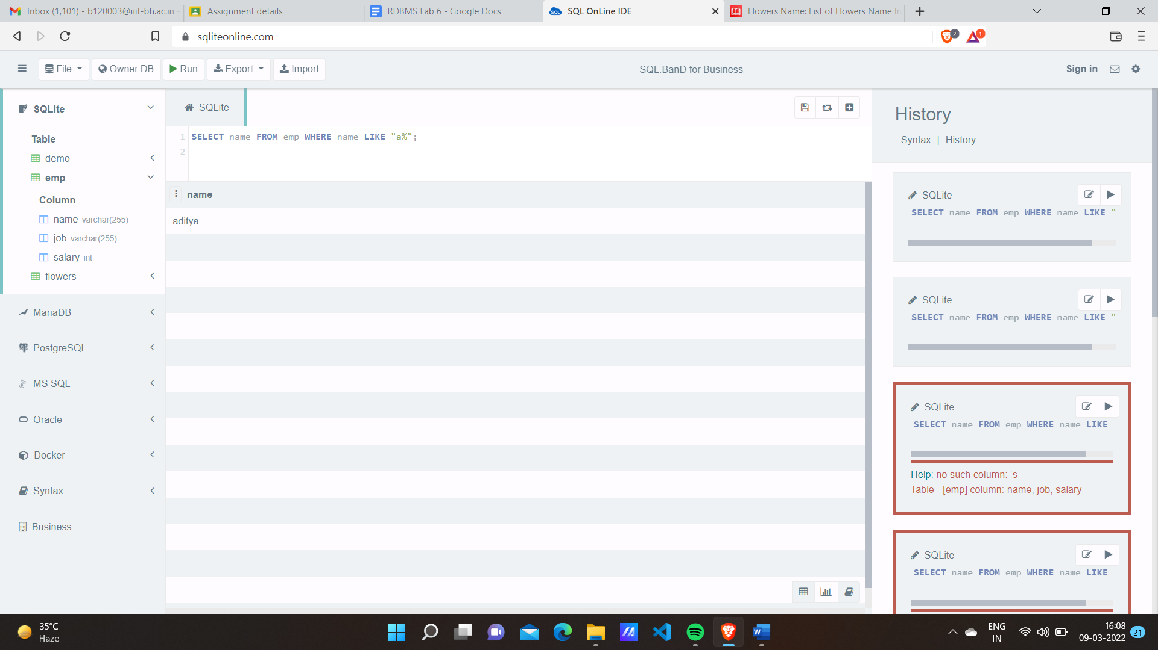

**EXAMPLE 2:**

**CODE:**

CREATE TABLE Students (

ID int NOT NULL,

NAME VARCHAR(255)

);

INSERT into Students VALUES(13,"arohi"),(71,"rishu"),(8,"simran");

select NAME from Students where NAME like "a%";

**OUTPUT:**

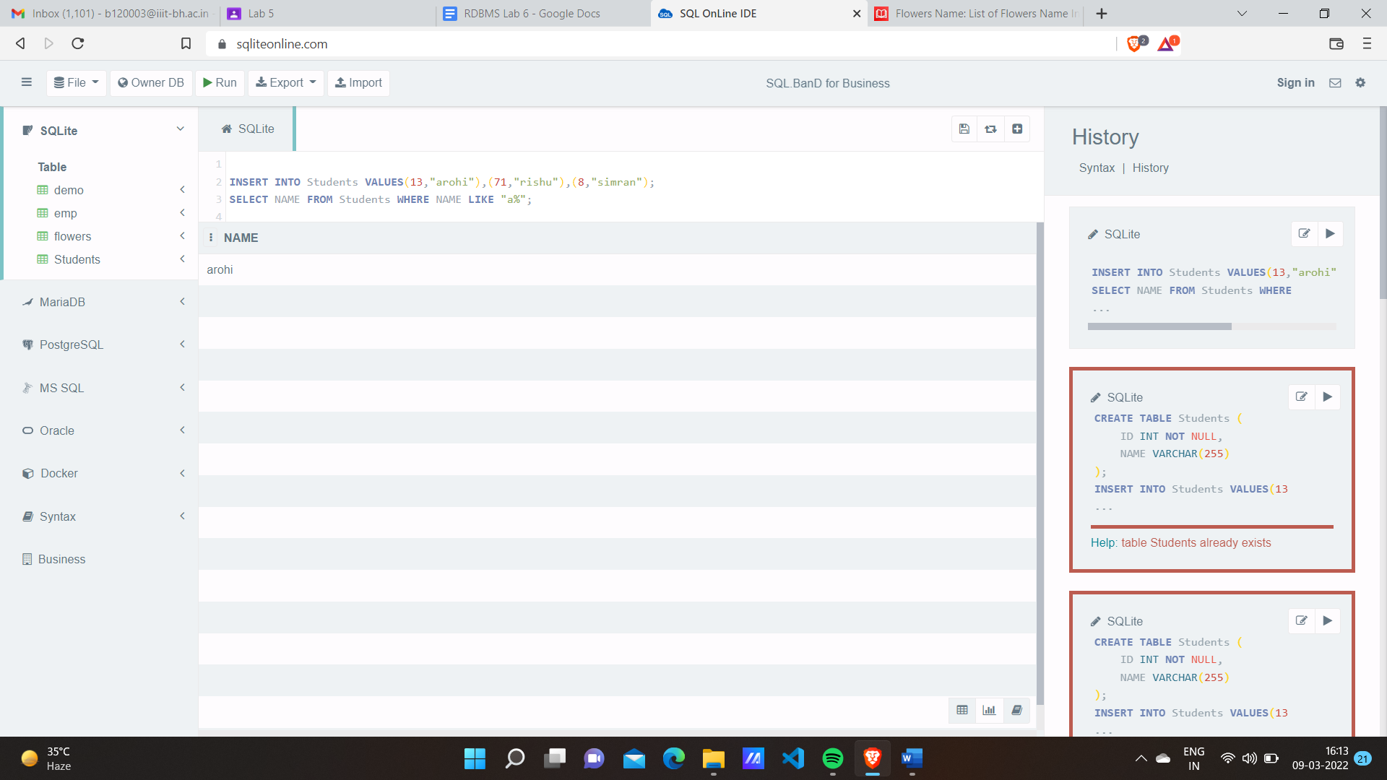

**6. List the numbers of people and average salary in deptno 30.**

N.B. First create several instances for different people in a dpt.

SQL>select count(*),avg (sal) from emp where deptno=30;

**7. Nested queries. Write a nested query to retrieve the First name.**

SQL> select Firstname from Persons p where lastname in (select lname from demo d where  p.lastname=d.lname)